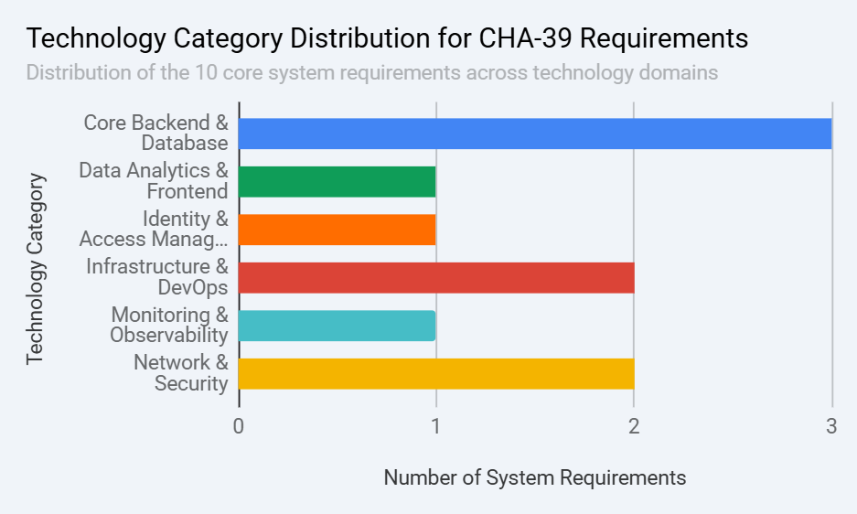

Based on the system requirements specified for CHA-39: Cybersecurity Portal for Effective Management of Servers and Firewalls (Data Center Infrastructure Management Portal), the 10 core functional requirements map into a well-distributed, multi-layered technology stack.

The Technology Category Distribution for CHA-39 Requirements chart illustrates how these requirements are distributed across different technology domains.

Key Takeaways

1. Core Backend & Database Form the Foundation
- Dominant Category: This domain represents the largest share of the system architecture, covering 3 out of the 10 system requirements (Software License Management, Hardware Inventory & Asset Tracking, and Integration & Automation).
- Recommended Stack: A robust relational database management system like PostgreSQL is ideal for maintaining structural integrity across hardware inventories, warranties, and software license allocations.
- Automation & Integration: To fulfill the integration requirements with external IT service management (ITSM) platforms and ticketing systems, a backend built on Python (Django/FastAPI) or Go, combined with Celery and RabbitMQ for asynchronous task queues, will ensure seamless API execution and background processing.

2. Network Security & Infrastructure Management are Heavily Prioritized
- Core Requirements Covered: This layer satisfies 4 critical requirements split evenly between Infrastructure & DevOps (Server Management, Load Balancer Management) and Network & Security (Firewall & Network Device Management, Security & Compliance).
- Network Automation: Centralized configuration of firewalls, switches, and routers can be achieved using network automation libraries like Netmiko or Ansible, interacting directly with vendor-specific APIs and standard protocols like SNMP and Syslog.
- Data Protection & Secrets Management: To secure sensitive infrastructure credentials and maintain compliance, a dedicated secrets manager like HashiCorp Vault should be implemented alongside TLS 1.3 encryption for data in transit and AES-256 for data at rest.

3. Specialized Modules Ensure Observability and Access Control
- Identity & Access Management (IAM): Satisfies the User Access and Identity Management requirement. Implementing an open-source IAM solution like Keycloak supporting OAuth2 / OpenID Connect allows administrators to enforce strict Role-Based Access Control (RBAC) and maintain comprehensive audit logs.
- Monitoring & Observability: Satisfies the Monitoring & Alerting requirement. A modern observability stack combining Prometheus (for metric collection) and Grafana (for visualization) provides real-time alerts on environmental conditions, hardware failures, and abnormal resource consumption.
- Data Analytics & Frontend: Satisfies the Reporting & Analytics requirement. A modern frontend framework like React paired with visualization libraries like Chart.js or an integrated analytics platform like Apache Superset will provide interactive dashboards and customizable reports for capacity planning.

